Be The Wall Recall Survey:
- Have you seen this logo before? YES or NO
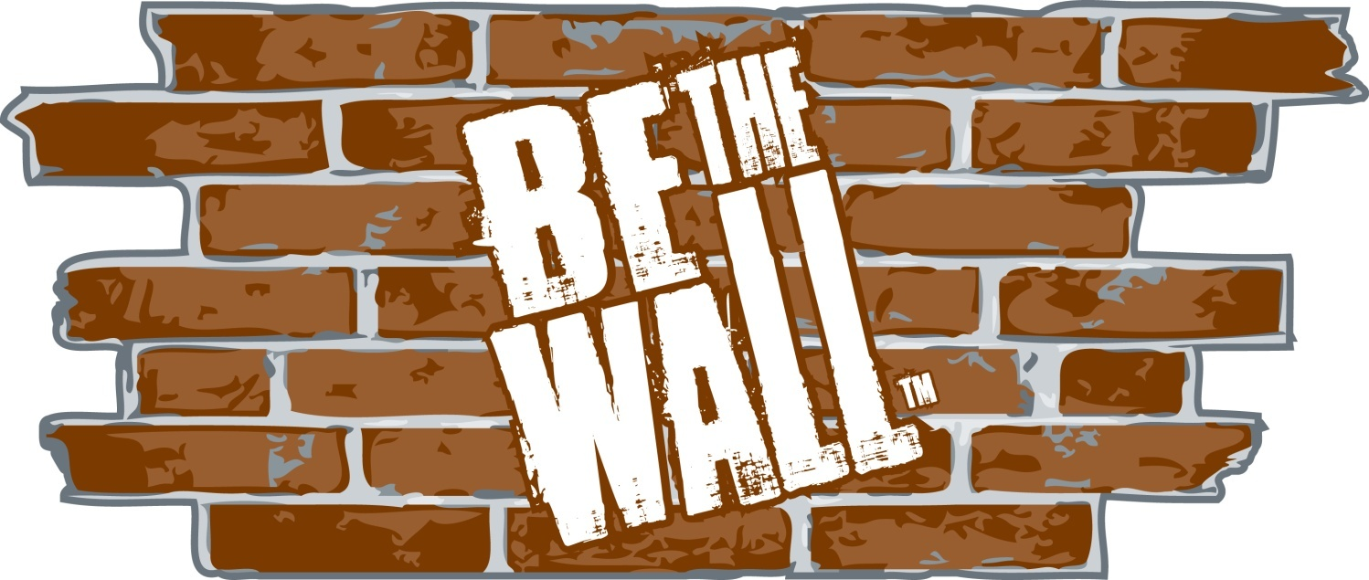

- This logo is used in the following campaign:
  - Teen Pregnancy
  - Homelessness
  - Alzheimer’s Disease Prevention
  - Underage Drinking Prevention
  - Drug Rehabilitation

- If you have seen this logo, where have you seen it?
 Port Charlotte Town Center Mall
 Cultural Center of Charlotte County
 Charlotte Sports Park-Stone Crabs Game
 Charlotte County Administration Bldg
 Charlotte County Public School(s)
 Punta Gorda Farmer’s Market
 Other: ______________________________

